Financial Aid and the Transition to College:

The Experiences of California High School Seniors in 2025

XXX, 2026

Jacob Jackson, Stephanie Luna-Lopez, and Christina Sun—California Education Lab

Jessica Moldoff and Ryan Fuller—California Student Aid Commission

Introduction

Financial aid plays a critical role in reducing the costs of college for students, helping make postsecondary education more accessible. It is also strongly associated with improved college outcomes, including higher rates of persistence and degree completion (Nguyen et al., 2019). In California, students apply for financial aid through the Free Application for Federal Student Aid (FAFSA). Eligible students may be offered state and federal grants (money for college that does not need to be paid back) as well as access to federal student loans and work-study programs. California students who are not eligible to complete a FAFSA may instead submit the California Dream Act Application (CADAA) to be considered for state and institutional financial aid, including the Cal Grant program.

The complexity of the financial aid process, including FAFSA completion, is well documented (Bettinger et al., 2012; Dynarski & Scott-Clayton, 2006). Recently, both the state and the federal government implemented reforms to improve the financial aid application process. In 2021, California Assembly Bill (AB) 469 established a new FAFSA policy that required school districts serving high school students to ensure that seniors apply for aid through the FAFSA/CADAA (or formally opt out of applying for aid). In 2023, the federal government introduced a redesigned FAFSA to reduce the form’s complexity and streamline the application process. However, the new form, which was launched during the 2024–25 financial aid application cycle, posed unforeseen challenges. The redesigned FAFSA launched 3 months later (on December 31, 2023) than it typically does each year (on October 1), and many students experienced technical problems while completing the new application. Our survey of high school seniors from the class of 2024 revealed that half of the respondents who successfully completed a financial aid application found the process somewhat or very difficult. As a result, many students—and the colleges trying to serve them—faced significant delays in receiving financial aid award letters and making informed decisions about college enrollment.

This report is part of an annual data-collection effort to document California high school students’ postsecondary plans and experiences with applying for financial aid. In spring 2024, the California Education Lab at the University of California, Davis, first partnered with the California Student Aid Commission (CSAC) and the Cradle-to-Career Data System to document the experiences of high school seniors as they transitioned to postsecondary education. The most recent web-based survey was emailed to all seniors statewide who completed the FAFSA/CADAA in spring 2025 and includes questions related to students’ high school experiences, their plans following high school, their perceptions of college affordability, and their experiences with applying for and receiving financial aid. Importantly, many of the same questions were included in both the 2024 and 2025 surveys, enabling us to track shifts in students’ experiences as the redesigned FAFSA rolled out. This report analyzes the responses of 6,812 students and highlights the importance of high schools in supporting students’ completion of financial aid applications. Results indicate that the second year of implementing the redesigned FAFSA for the 2025–26 cycle saw some improvements. Overall, there was an 11% increase in FAFSA/CADAA submissions compared to 2024–25 (CSAC, 2025), but the class of 2025 still faced a later FAFSA release date than typical (November 21) and other ongoing challenges.

Financial Aid Application for the Senior Class of 2025

Students begin making decisions about higher education well before they graduate from high school. Learning about college and the availability of aid helps students make informed choices and take the steps necessary to ensure college eligibility. With this in mind, we asked students to recall when they first heard about the FAFSA/CADAA. About two-thirds (67%) of respondents reported hearing about financial aid applications before their senior year, and just over one-third (36%) reported hearing about the FAFSA/CADAA during their freshman or sophomore year (Figure 1). These rates are up from 2024, suggesting that the new FAFSA/CADAA policy (AB 469) may be improving—or at least accelerating—high school students’ awareness of financial aid. Nevertheless, given that one-third of students reported learning of financial aid during their senior year, there remains an opportunity to improve and broaden sharing of information about college access earlier in high school.

Figure 1. Timing of First Knowledge of the FAFSA/CADAA by Year (2024 vs. 2025)
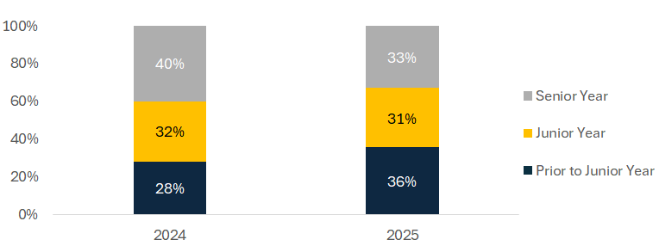
Note. Responses to the question: When did you first hear of the FAFSA or CADAA? 2024: N = 11,328; 2025: N = 6,798.

There are significant variations in awareness of the FAFSA/CADAA by parental education level (Figure 2). About 72% of continuing-generation respondents reported hearing about the FAFSA/CADAA before their senior year, compared to 61% of first-generation respondents. Both first-generation and continuing-generation students in the 2025 graduating cohort were about 5 percentage points more likely to have learned about the FAFSA/CADAA prior to their junior year than respondents in the 2024 graduating cohort. Despite this increase in awareness earlier in high school, a persistent information gap remains between first-generation and continuing-generation students.

Figure 2. Timing of First Knowledge of FAFSA/CADAA by Parental Education Level (2024 vs. 2025)
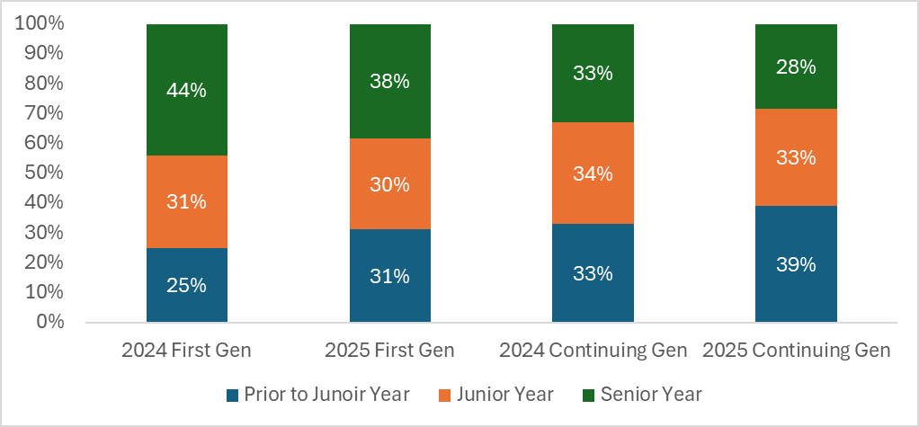
Note. Responses to the question: When did you first hear of the FAFSA or CADAA? Not all respondents reported a parent’s education level, and some indicated they didn’t know, reducing the sample size. 2024: N = 11,238; 2025 N = 5,125.

When students learned about the FAFSA/CADAA also varies across California’s 10 regions (Figure 3). In areas such as Los Angeles County, the Central Coast, the San Francisco Bay Area, and the San Diego–Imperial region, almost 70% of students had heard of the aid applications before their senior year. In contrast, students in the Superior region, Northern San Joaquin Valley, Southern San Joaquin Valley, and North Coast were more likely to learn about the FAFSA/CADAA during their senior year, with 41%– 44% of respondents in those regions reporting that they first heard about financial aid applications during their senior year, compared to 31%–33% in other regions. These differences suggest that some regional-based efforts may help increase FAFSA/CADAA knowledge and applications across the state.

Figure 3. Percentage of Students Who Learned About FAFSA/CADAA Prior to Their Senior Year (by Region)
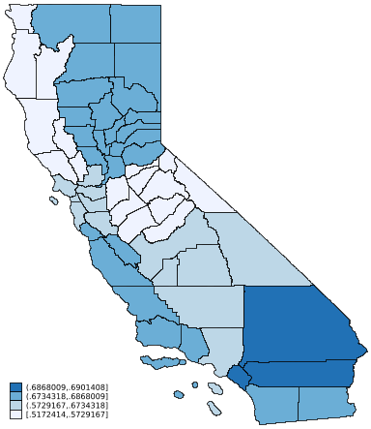

Note. Responses to the question: When did you first hear of the FAFSA or CADAA? Regional percentages represent the combined percentages of students who heard about the FAFSA/CADAA prior to or during their junior year. N = 4,826.

Students generally complete the FAFSA/CADAA with the explicit intention of applying for aid for college; however, with the new California FAFSA/CADAA policy (CSAC, n.d.), some students may complete the FAFSA/CADAA simply because it is mandated for high schools, and thus their school required it. Students were surveyed about their motivations for completing financial aid applications. The findings indicate that most students (61%) completed aid applications to determine their eligibility for financial aid (Figure 4), 39% indicated that they completed the FAFSA/CADAA because it was a graduation requirement, 26% said it was an expectation at their high school, and 9% said it was a class assignment. Students can select multiple reasons for filling out an aid application, and when taken together, 60% of students indicated that completing the FAFSA was a graduation requirement, an expectation at their school, and/or a class assignment. Students were therefore just as likely to apply for aid at least in part because they were required or expected to (60%) as they were to find out about financial aid eligibility (61%).

Figure 4. Reasons Students Completed the FAFSA or CADAA
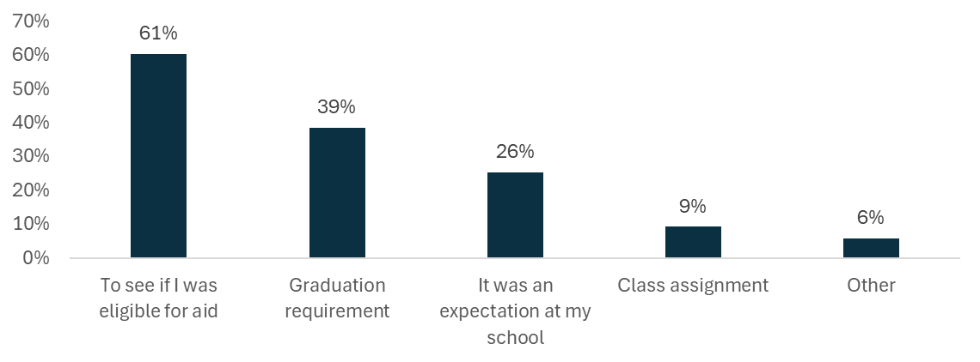
Note. Responses to the question: Why did you complete the FAFSA/CADAA? N = 6,796. Categories do not add to 100% because students could select more than one category.

In students’ responses to open-ended questions, they shared details about their reasons for completing the FAFSA. One student wrote:

I completed the FAFSA because I need financial aid to continue my education. Without it, I wouldn’t be able to afford college and I might have to give up on my dream of going to college and just work instead.

Students from racial and ethnic groups that have been historically underrepresented at college—as well as first-generation students—were more likely to complete the FAFSA/CADAA because of school requirements or expectations (Figure 5). Specifically, a larger proportion of Black (63%) and Hispanic/Latino (62%) students cited high school requirements as their reasons for completing the aid applications compared to their Asian (57%) and White (47%) peers. The likelihood of first-generation and continuing-generation students to fill out an application because their school expected or required it was about the same.

Figure 5. Percentage of Students Indicating That School Expectations or Requirements Were a Reason They Applied for Aid by Student Demographics
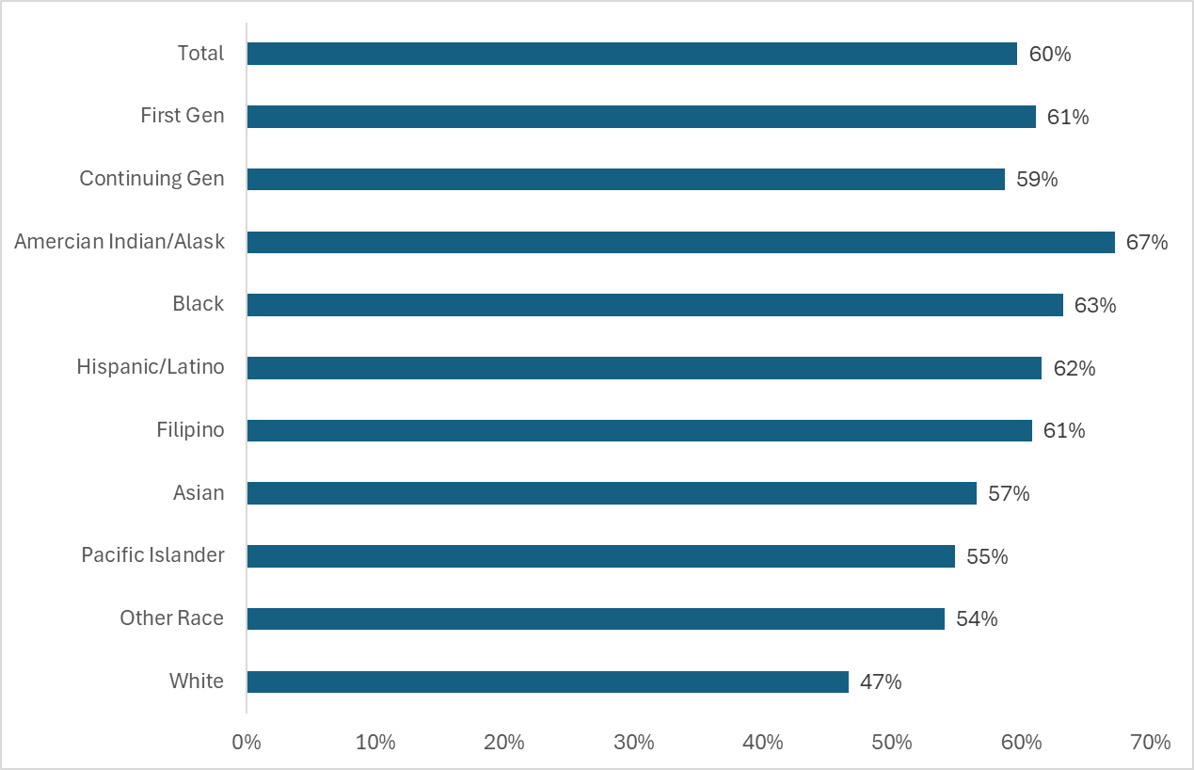
Note. Responses to the question: Why did you complete the FAFSA/CADAA? Subsample includes those who selected the responses “It was a graduation requirement at my school,” “It was an expectation at my school,” and/or “It was a class assignment.” N = 6,796.

Challenges With Applying for Financial Aid

As prior survey results indicated, some students and families encounter difficulties when filling out the FAFSA. For example, in 2024, students completing the FAFSA were often hampered by technical problems, having to fill out or submit the application multiple times, or difficulty adding parents or financial contributors to their applications. Mixed-status families (whose family members had differing immigration and citizenship statuses) experienced particular issues with submitting the form. These challenges appear to be waning. In 2025, approximately 71% of respondents said that applying for financial aid was very easy or somewhat easy compared to only 51% of students in 2024 (Figure 6). Furthermore, the share of students who found the application very difficult decreased from 12% in 2024 to 3% in 2025, while the share who found it very easy increased from 10% to 17%.

Figure 6. Difficulty of Applying for Financial Aid (2024 vs. 2025)
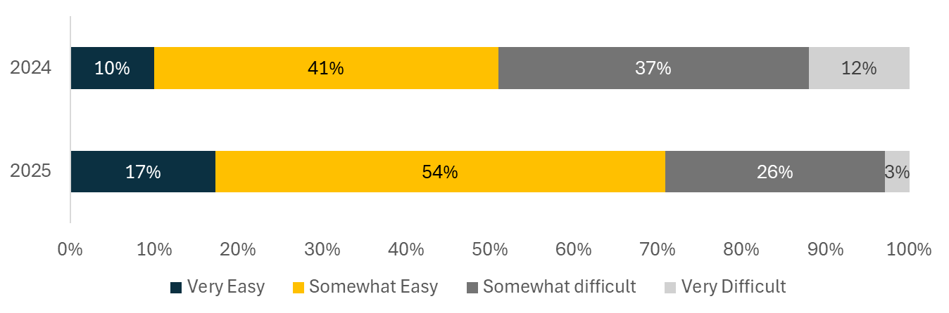
Note. Responses to the question: How difficult was it to apply for financial aid? 2024: N = 10,744; 2025: N = 6,452.

These improvements in the experience of applying for financial aid appear to be widespread across student subgroups and geography. However, difficulties in the application process were more pronounced for some subgroups. Figure 7 shows that 32% of first-generation students reported that applying for financial aid was somewhat or very difficult, compared to 26% of their continuing-generation peers. Pacific Islander and Hispanic/Latino students were also more likely to find applying for aid somewhat or very difficult compared to the average student in the state.

Figure 7. Difficulty of Applying for Aid by Student Demographics
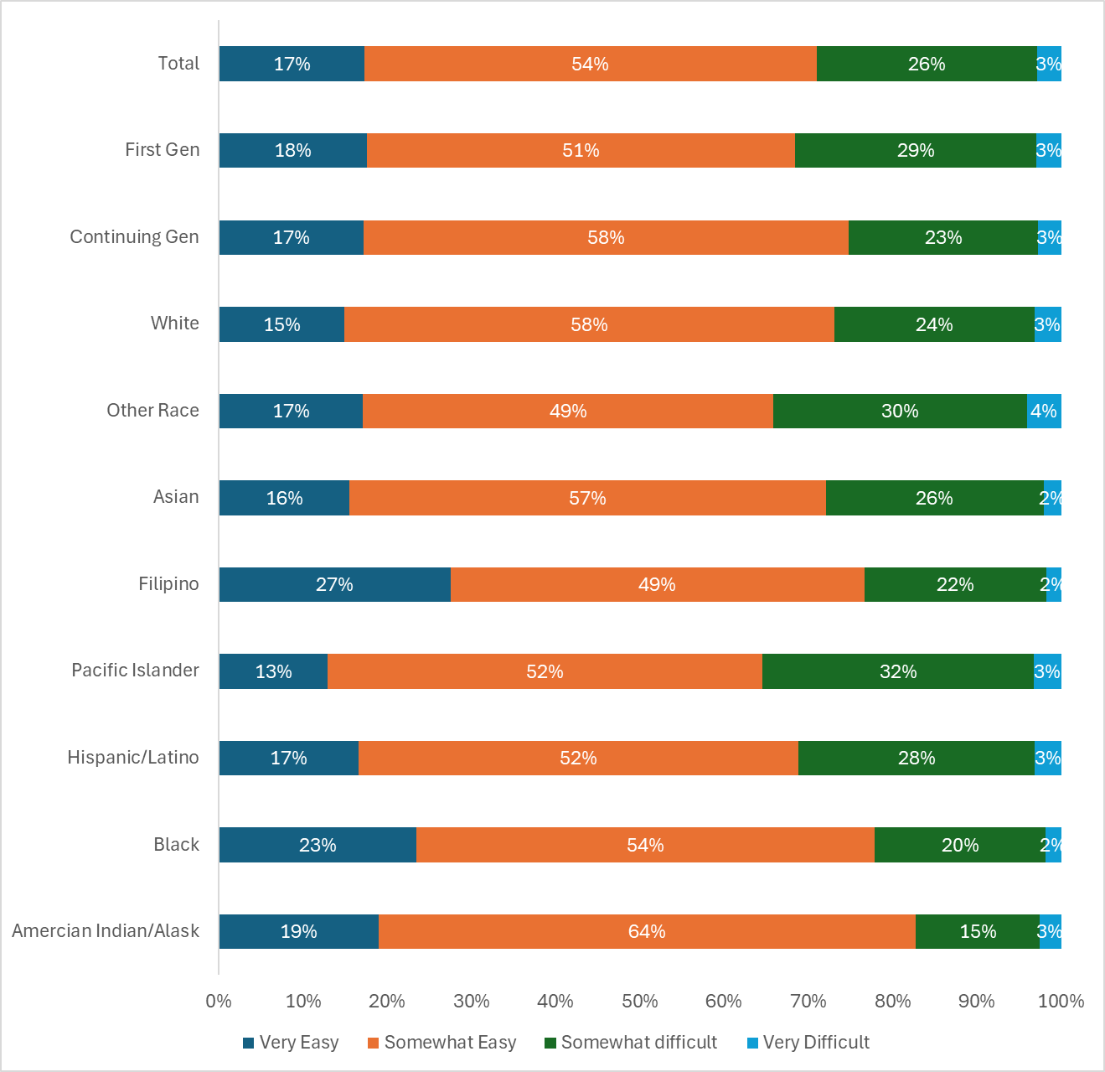
Note. Responses to the question: How difficult was it to apply for financial aid? N = 6,452; students who chose a parental education level: n = 5,002; students who chose a race category: n = 5,499.

Students identified several types of challenges they faced when applying for financial aid. Nearly one quarter of respondents (23%) found the application confusing, 15% had issues with financial contributors (most often their parents), and 11% said it took them multiple attempts.

One student who experienced technical challenges noted:

The site just didn’t save the information several times and the site overall was just so glitchy. I filled it out as soon as it opened too, it wasn’t due to heavy use.

Compared with the graduating class of 2024, respondents from the class of 2025 reported a significant improvement in many of the previously identified difficulty areas. In 2025, 42% of seniors reported no difficulties, compared to 25% in 2024 (Figure 8). The percentage of survey respondents reporting technical difficulties with the FAFSA also declined from 34% in 2024 to 15% in 2025. Likewise, the percentage of respondents reporting multiple submission attempts decreased from 24% to 11% between the 2024 and 2025 graduating cohorts.

However, respondents in 2025 were more likely to be concerned about sharing their family’s information with the federal or state government than they were in 2024. FAFSA applications leverage IRS data, sending additional financial data to the federal government, while information on the CADAA is shared only within the state of California. This rising reluctance to share family information with the government is consistent with a well-documented pattern in which immigration enforcement reduces immigrant families’ engagement with government programs (Alsan & Yang, 2022; Watson, 2014); the percentage of respondents who cited this concern increased from 12% in 2024 to 17% in 2025. The data from this survey do not reflect those students who opted not to apply for financial aid at all due to privacy concerns.

Figure 8. Challenges Students Faced When Applying for Financial Aid (2024 vs. 2025)
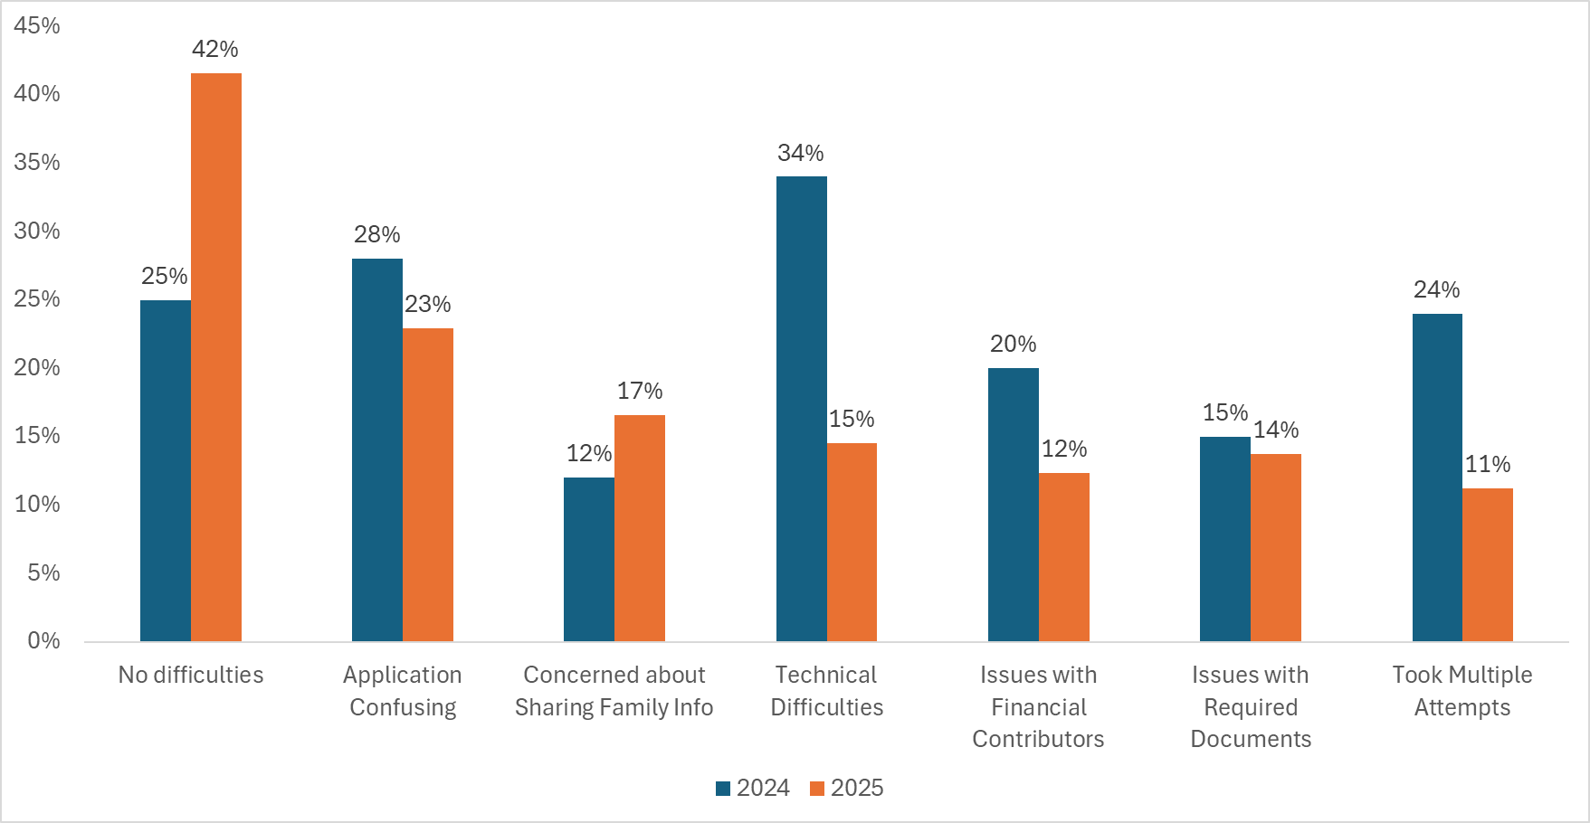
Note. What challenges did you face when applying for financial aid? 2024: N = 10,701; 2025: N = 6,750. Categories do not add to 100% because students could select more than one. The following categories were omitted from the figure because the same rates were reported in 2024 and 2025: “Didn’t know which application to complete,” “Couldn’t find someone to help,” and “Other”; fewer than 8% of students selected these options each year.

Financial Aid Application Supports

Regardless of whether students find completing the aid applications to be somewhat easy or challenging, they often seek support when applying for aid. Students relied most heavily on high school counselors (45%) and their parents (44%). Respondents also indicated that workshops at their high schools (25%) and teachers (24%) supported their application process, while fewer students reported receiving help from other family members (16%), online resources (10%), friends (9%), and community workshops (6%).

The sources of support differed substantially by student subgroup (Figure 9). Two thirds of continuing-generation respondents relied primarily on parents (67%), while first-generation respondents drew support from a broader network of school-based resources, including high school counselors (52%), high school workshops (29%), and teachers (28%). These findings underscore the importance of school-level support for first-generation students.

Figure 9. Financial Aid Supporters by Parental Education Level
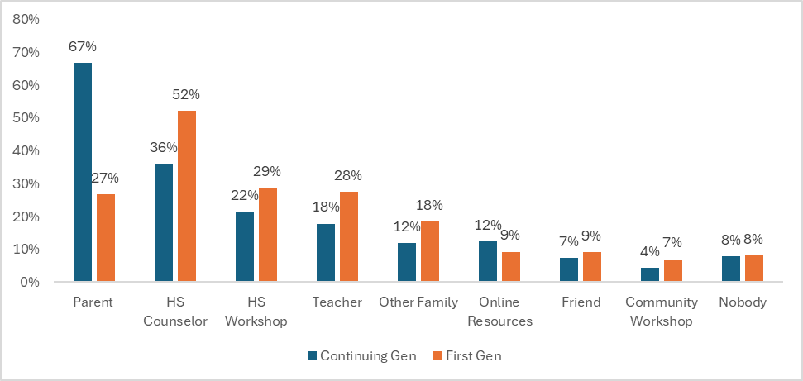
Note. Responses to the question: Please tell us about the support you received in completing your FAFSA/CADAA. N = 5,120. Categories do not add to 100% because students could select more than one category.

Regional differences also emerged in students’ reported sources of support. Students from Northern and Southern San Joaquin Valley reported the highest rates of support from high school counselors, whereas students from the Superior, San Francisco Bay Area, San Diego–Imperial, and Orange County regions relied more heavily on parents for assistance with their financial aid applications (Figure 10). A larger proportion of students in the San Joaquin Valley are first-time college students, compared to students in the San Francisco Bay Area, San Diego–Imperial, and Orange County, where respondents were more likely to be continuing-generation students. Even among only first-generation students, students in Northern and Southern San Joaquin Valley were most likely to rely on counselors for FAFSA/CADAA support.

Figure 10. Regional Responses to Parental and High School Counselor Support
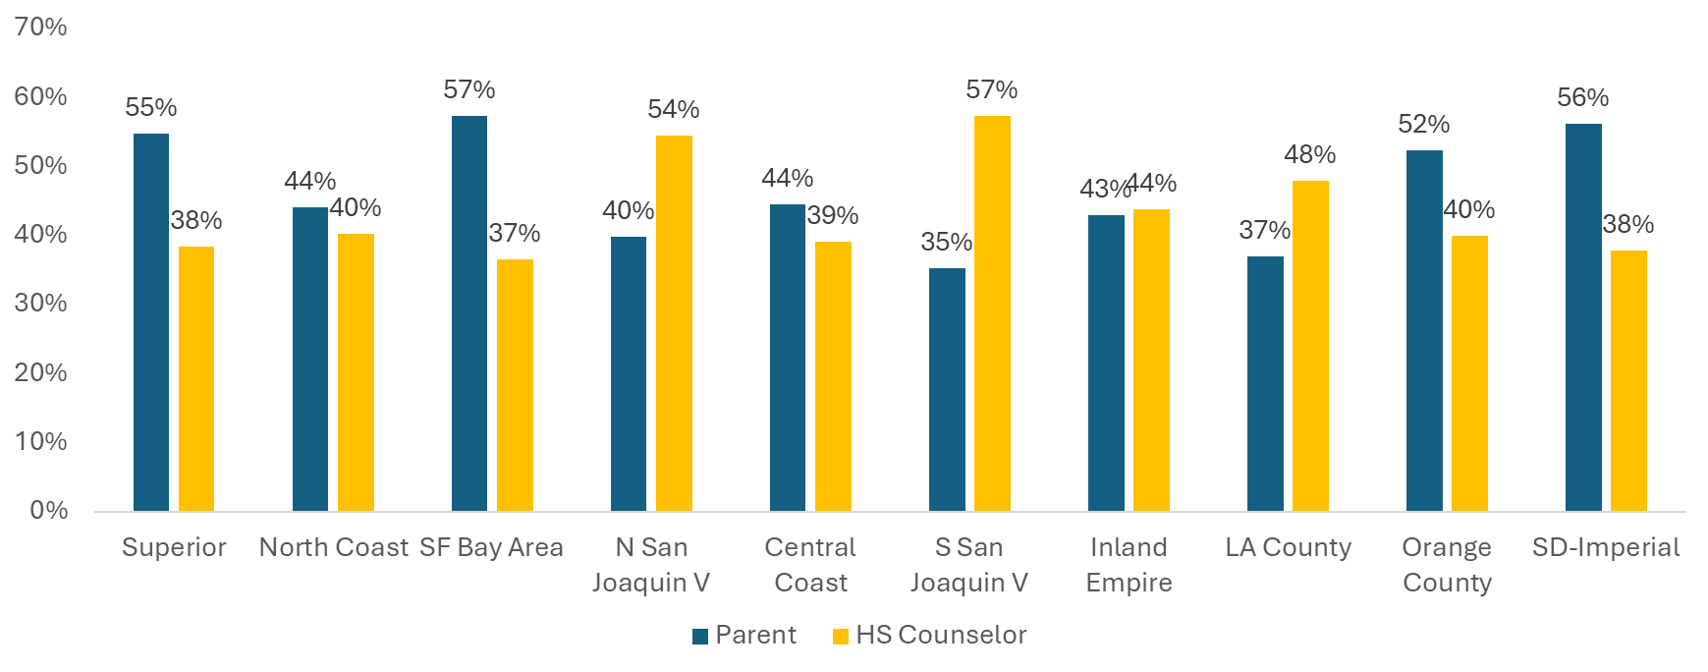
Note. Responses to the question: Please tell us about the support you received in completing your FAFSA/CADAA. Subsample of students who indicated parental or high school counselor support: N = 4,820. Categories do not add to 100% because students could select more than one category.

Affording College

To make the most informed decisions on whether to apply to college and where to enroll, high school seniors need clear information about the potential costs. Although all students in our survey applied for financial aid, not all students had received responses from colleges about their aid options by the time they graduated. On average, 30% of respondents were contacted via email, letter, or phone about financial aid by all the colleges to which they applied by the time they took this survey (May 2025 through July 2025). Approximately 41% were contacted by at least one college, and 29% were not contacted by any college to which they applied. Among those who were contacted about their financial aid, the majority of students surveyed (62%) were given details about grants and scholarships, 42% received information about loans, and 29% were informed about work-study eligibility (Figure 11). In addition, 60% of students were contacted about FAFSA/CADAA verification.

Figure 11. Students’ College Contacts About Financial Aid
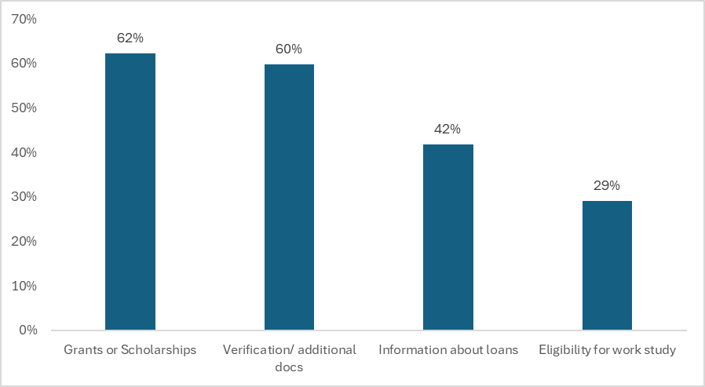
Note. Responses to the question: What did the colleges contact you about regarding your financial aid offer? N = 3,987. Categories do not add to 100% because students could select more than one category.

Survey respondents planned to use a variety of methods to pay for tuition, fees, and other expenses associated with attending college (Figure 12). More than half of respondents intended to work to pay for college regardless of where they planned to attend. About half of students expected to use grants, with a higher proportion planning to attend an in-state 4-year college or university (California State University, University of California, and private 4-year institutions). In contrast, students planning to attend college outside California were much less likely to depend on grants. Students planning to enroll in private, out-of-state, and University of California (UC) colleges were also more likely to use scholarships to pay for tuition costs. A little over one third of students planned to use their own savings, with those attending private institutions in California somewhat more likely to do so. In contrast, overall, fewer than one third of students planned to use loans to pay for college costs; those planning to enroll in community colleges were the least likely to do so, whereas those enrolling in private institutions or colleges outside California were more likely. Students were unlikely to use credit cards, with approximately 5%–6% expecting to do so regardless of institution type.

Figure 12. Students' Sources of Funding for College by Application Destination
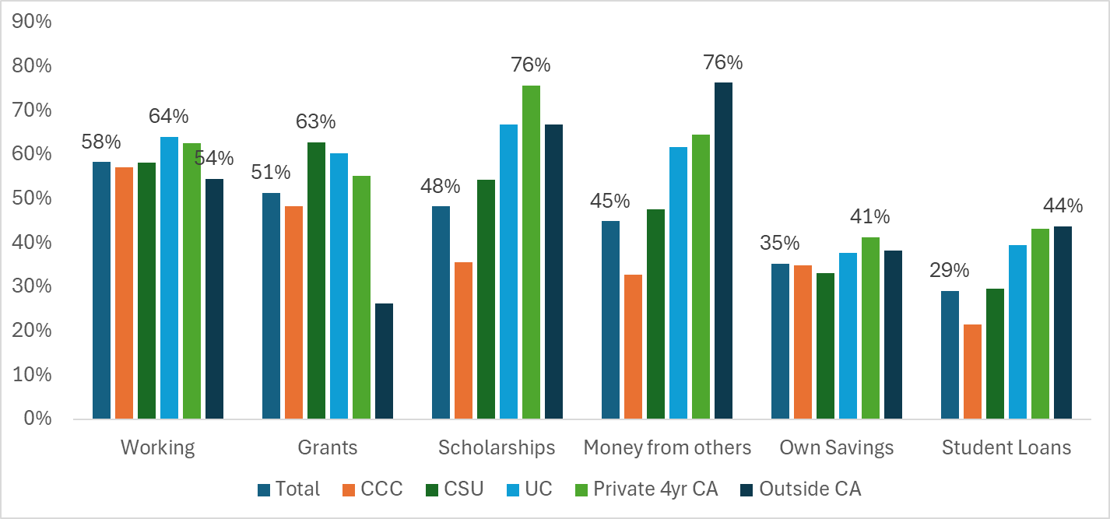
Note. Responses to the question: How do you plan to pay for college tuition? Only students who selected a likely college destination are included in this sample; N = 5,594. Categories do not add to 100% because students could mark multiple categories. About 5% of students planned to use credit cards, and about 2% of students planned to use military benefits; those rates did not vary much across college types. CCC = California Community Colleges; CSU = California State University; UC = University of California.

Worries About College

Students have many concerns about the transition to college (Figure 13). Overall, students’ top concerns centered around affordability, with 42% of respondents very worried about affording tuition and 39% very worried about affording living expenses. In contrast, only one in five students were not at all worried about affording college. Beyond affordability, respondents tended to be less worried about other transition hurdles, such as getting good grades (31% very worried), balancing work obligations (30%), finding community (23%), finding support for their mental health (18%), balancing family obligations (16%), and living away from home (14%).

Figure 13. Students’ Concerns About the Transition to College
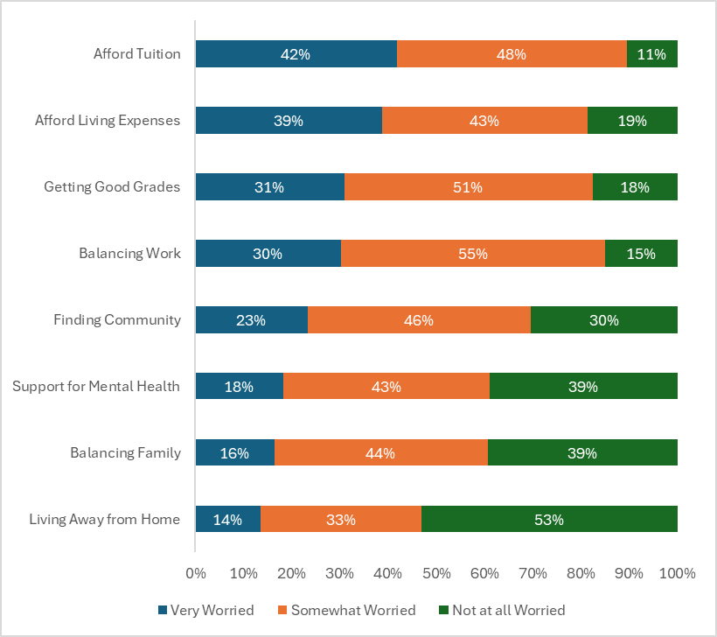
Note. Responses to the question: When you think about college, how much are you worried about the following? N = 5,497.

Students’ concerns differed somewhat by where they planned to attend college (Figure 14). Concerns about affording tuition were widespread, with roughly 40%–48% of respondents very worried regardless of institution type. However, respondents planning to attend a UC campus were more likely to be concerned about living expenses compared to respondents planning to attend other institutions. About one third of students were very worried about balancing work and college at all institution types, except those attending college out of state, who were much less likely to be very worried.

Figure 14. Top Affordability Concerns by Application Destination
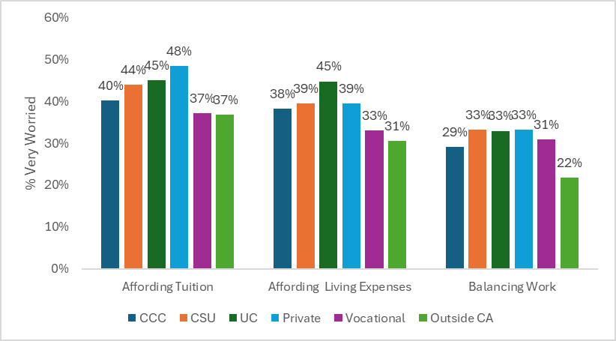
Note. Responses to the question: How much are you concerned about the following? Graphs indicate the percentage of students who are very worried in each category. N = 5,524. CCC = California Community Colleges; CSU = California State University; UC = University of California.

In open-ended questions, the cost of living and affordability were among the most frequently cited concerns for students. Despite receiving financial aid, many students are still expected to pay out of pocket for school supplies, transportation, and utilities, among other expenses. Students reported concerns about taking out loans. In some cases, students expressed worries about not being able to participate in activities or pursue goals due to financial constraints:

The biggest challenge I will face is money problems. Whether that is having no money to be in clubs or hang out with friends, or having to take out loans to pay for overall college expenses.

My biggest challenge would be trying to afford college because FAFSA is not giving me a lot of money so I need to get a job to be able to pay off my school but I’m really grateful that I have my mom to help me pay half of my school.

Money. My parents work their hardest to maintain a good life for not only me and my sister but themselves too. We don’t have money to spend and we don’t have any savings. I want to accomplish all the things I’ve set out to [but] it’s just hard because I might have to put some things off because I literally can’t afford it.

The transition to college may also stir feelings of anxiety, fear, and excitement. Beyond affordability, respondents expressed concern over social, emotional, and academic challenges they anticipated facing in college. Like the class of 2024, survey respondents this year worried about maintaining a healthy work-life balance and staying motivated throughout their college career:

The biggest challenge I will face in college will be managing my time and trying to find a balance between academics, social life, work, and more. I fear that I will be overwhelmed by the pressures and responsibilities that I have to endure to achieve my goals and to become successful in college.

As I am attending community college, it may be difficult to stay motivated to continue pursuing my path towards attending a 4-year university, as roughly 80% of those who intend to transfer from a CCC to a CSU or UC don’t reach that goal. However, I am confident that I can stay motivated and continue to work towards my goals.

Socialization was also a concern for students. They reported feeling nervous about making new friends and finding community in a new environment. Additionally, some English learners were worried about improving their English language skills:

I’m anxious about a multitude of things in regards to college; moving away from home, adapting to a new environment, finding new people, tackling every course, etc. I know I am not alone in this experience and it is something I will need to remind myself while at college.

Una dificultad sería el idioma ya que el Inglés no es mi primer lenguaje y estos años de estudio han sido difí­ciles por el idioma pero aún así he podido cumplir mi escuela y otra dificultad serí­a el pago de el colegio ya que no tengo una economã­a estable con mi familia. [One challenge would be the language since English is not my first language and these years of schooling have been difficult due to the language but I have still been able to complete my schooling. Another difficulty would be the college payment since my family is not financially stable.]

Although high school provides structured support and readily available guidance from counselors and teachers, college independence requires students to seek out the information and resources they need to solve problems and complete processes on their own. Some students were concerned about lacking support and learning to navigate college alone:

Adjusting to needing to seek out information on my own, instead of being given what I need like in high school.

Managing my mental health—it’s been a difficult ride for me in high school due to my dysthymia, panic disorder, autism, and ADHD, so I’m hoping that I’ll have good resources that support my journey to mental wellness alongside my academic goals.

Doing it mostly alone. I have people who love and support me but this will be my first time away from anyone I know doing things by myself. I think having to keep everything running smoothly with only minimal support from afar will be my biggest challenge.

Despite the numerous concerns that students describe, respondents from the 2025 graduating cohort were slightly less likely to be very worried about each area than those in the 2024 cohort (Figure 15).

Figure 15. Students’ Concerns About College (2024 vs. 2025)
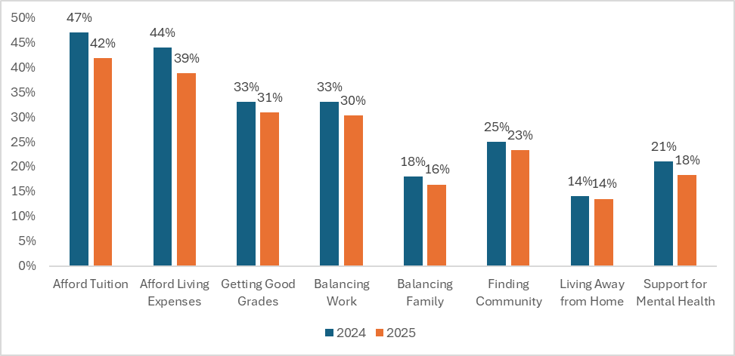
Note. Responses to the question: How much are you concerned about the following? Graphs indicate the percentage of students who are very worried in each category. 2024: N = 8,350; 2025 N = 5,530.

Student Voices: Excitement About College

Overall, students were excited to embark on their college journeys. Like the class of 2024, students this year were looking forward to becoming independent and to growing academically and professionally. In some cases, students expressed excitement about the opportunity to be their authentic selves and explore their identities:

What excites me most about college is the next step into what I have dreamt of pursuing my whole life. But while pursuing it, I find new ways to make use of myself and discover new opportunities to grow. I have learned in high school that everything is not given to you, you must work hard to earn this and along the way, there are many generous people [who] will help you get there. I’m so glad to be able to move on with my journey, and only he knows what’s next for me!

What excites me most about college is the opportunity to grow both personally and academically. I am also looking forward to the independence, new friendships, and experiences that will help shape me into the person I am meant to become.

Lo que más me entusiasma de la universidad es que tendré un nuevo comienzo, lleno de oportunidades para mi crecimiento profesional y académico. La emoción de explorar diferentes campos de estudio, conocer gente nueva y participar en actividades. [What excites me the most about college is that I’ll have a new start, full of opportunities for my professional and academic growth. The excitement of exploring different fields of study, meeting new people, and participating in activities.]

The transition. I’ll be getting a car soon. I feel like learning to manage my time to be able to take myself to school plus drive my siblings around will be a lot. Overall, maintaining a healthy lifestyle between my friends, family, and my boyfriend but also myself will be the hardest. Not overly stressing myself out with all these plans plus studying and managing to keep a social life while working.

By the time I get there I’ll have a separated distance between me and my father, so I should theoretically be able to be more open about my gender identity in his absence—perhaps even being able to get an HRT prescription before the feds try to make it illegal.

First-generation and low-income college students looked forward to the benefits a college degree offers, including the opportunity to break cycles of poverty and serve as role models in their communities:

What excites me the most about college is that I will be first generation and will be able to share this journey and experience with my family. Also, this is something completely new and out of my comfort zone so I am looking forward to challenging myself, learning new things, more activities, and meeting new people.

Being able to break the cycle of my family members believing they cannot and are not welcome in a college setting. I am excited to be a role model for the youth in my community and family.

All the financial help the school is giving me and being the first in my family to have the opportunity to attend college, and also the help the college staff is giving me as an immigrant student and having English as my second language.

Finally, participants looked forward to the social aspects of college, such as making new friends, exploring new environments, and trying out extracurricular activities:

I am excited to explore all that was out of reach for me before, both in and out of the classroom. I can’t wait to learn more about topics I am passionate about, be able to be more involved in my school and local community, and also meet new people.

I want to make new friends and learn a lot about my career choice, because I want to be able to support myself financially and have what I want without having to worry about money all the time.

Aprender sobre mi carrera y estar en una nueva etapa de mi vida y tener una buena comunidad ser aceptada en un nuevo lugar y poder cumplir una de mis metas que es terminar mis estudios. [Learn about my career and be in a new phase of my life and have a good community. Be accepted in a new place and be able to achieve my goals of finishing my studies.]

I think being in an in-person class setting again. I attended high school through an online independent study school, so it will be exciting to be surrounded by peers again. Also, just being around people who have the same interests as me and who want to pursue the same things. The idea of college just is exciting in itself: making new friends, learning new things, experiencing new things, being more independent. It’s the next chapter of my life and it excites me (and also scares me, but still).

Overall, students’ excitement about college reflects their hopes for independence, growth, and new opportunities. Whether they are pursuing their passions, supporting their families as first-generation students, or building new communities, these students see college as a chance to shape their futures and discover who they want to become. Their eagerness highlights the transformative potential of higher education and the importance of supporting students as they pursue postsecondary degrees.

Discussion

For high school students planning to attend college, affordability can be a significant barrier to entry. Regardless of students’ postsecondary plans, completion of the FAFSA/CADAA can provide critical information about aid eligibility and costs that can affect students’ college and career choices.

The financial aid application process in 2025 showed significant improvements over the previous year. Findings from this statewide survey of high school seniors indicate that students had fewer problems with the updated FAFSA in 2025 compared to the initial rollout of the revised application in 2024. Despite improvements in the process this year, about one third of respondents still found completing the applications either somewhat or very difficult, and about 58% encountered at least one challenge.

The survey results reveal that schools play an important role in helping students complete financial aid applications and supporting them as challenges arise. Students relied on multiple networks for support when filling out their applications, including school personnel and individuals within their communities. Notably, incoming first-generation college students, along with Black, American Indian/Alaska Native, and Hispanic/Latino students, were more likely to draw on school and community resources for support with the financial aid process.

Substantial differences also emerged across regions; students in some regions (Northern and Southern San Joaquin Valley and the Central Coast) were more likely to rely on high school workshops, even when accounting for differences between first-generation and continuing-generation students, than students in other regions. Schools in those regions, which tend to be more rural, may have developed different strategies for their students. For example, the California Student Opportunity and Access Program (Cal-SOAP) is a state-funded initiative working across 16 partnerships with school and community agencies to provide vital information about college costs and financial aid, including how to address the needs of underserved students and communities and foster greater equity in postsecondary access.

As many students continue to rely on counselors and school-based workshops during the financial aid application process, schools should plan for sustained support for FAFSA/CADAA submission by strengthening staff training related to the application process and expanding workshop offerings, potentially in multiple formats (e.g., in person, virtual, on demand). Since first-generation students and those from traditionally underrepresented racial and ethnic groups are more likely to use school and community resources, there is a need for continued proactive support beyond the application itself, including help with translating financial aid information, understanding timelines for award receipt and disbursement, and planning to bridge any remaining gaps in funding.

The survey results indicated that, on average, students are learning about the FAFSA/CADAA earlier in high school, even more so in 2025 compared to the class of 2024. Nevertheless, one third of students said that they first heard about financial aid applications during their senior year, which limits their time to research, plan, and identify the best approach for financing their higher education. This experience is more common among students who would be the first in their family to attend college, which suggests that opportunities remain to expand the timing and the information that schools provide to students, especially to students from traditionally underrepresented groups or who may otherwise have difficulty obtaining accurate information.

Although the survey results regarding improvements in the FAFSA/CADAA application experience are promising, affordability remains a primary concern for high school students making the transition for college. Affordability concerns were widespread across all types of institutions, but especially so for students who planned to attend more expensive schools, such as UC and private institutions.

There is still work to be done with encouraging students to apply for aid, as evidence indicates that one quarter of high school students did not apply and therefore do not have complete information about the postsecondary options that may be available and affordable to them. Respondents in 2025 expressed increased concerns (relative to the prior year) about sharing their family’s financial information with the state or federal government, which may be one explanation for why some students did not apply. These students may be responding to the current political climate, in which there is uncertainty about how the government will use sensitive information on aid applications, especially if a student has mixed-status family members. Managing student concerns and protecting their information will therefore be essential to ensure that all students have the opportunity and confidence to complete an application for financial aid. Providing students with the option of applying for state aid independently from federal financial aid may be one way to ease students’ concerns. Without such protections or alternative options, eligible students may forgo aid, including grants and loans, that could make college more affordable and accessible.

California is headed in the right direction with financial aid applications, as the growth in application submissions demonstrates. Yet affordability remains the number-one concern for high school seniors. California policymakers and educators should continue to facilitate completion of the FAFSA/CADAA. This survey has highlighted the importance of the role that schools and school personnel play in that process, especially for first-generation students and students who are Black, Hispanic/Latino, and American Indian. Given the importance of financial aid in college selection, affordability, and success, it’s possible that growth in aid applications, leading to expanded receipt of aid, could help close some of California’s long-standing postsecondary gaps in college attendance.

Appendix: About the Survey

Survey Construction and Administration

The online survey consisted of 58 questions, although respondents did not see every question because some were displayed only after a specific prior answer was selected. The questions consisted of a combination of Likert scale questions, selected-response items, and open-ended text responses. The survey was created in Qualtrics and administered via an anonymous survey link emailed to students. The survey remained open from May 28 to July 11, 2025, to include students who completed the FAFSA over the summer.

Population, Respondents, and Analytical Sample

The survey was sent to the population of students who filed and completed the FAFSA
or CADAA during the 2025–26 cycle. Students reported on various dimensions of their preparation and plans for the future. In response to open-ended questions, students described in their own words the challenges and excitement they anticipated before starting college.
We present data from the 6,980 survey respondents who indicated they were high school seniors at the beginning of the survey. Seniors were asked about their intent to enroll in college in fall 2025. Those who intended to enroll in college were then asked about their college plans; these students compose our sample for this report. We also capture differences in student experience by self-reported race/ethnicity, gender identity, and parental education level. This research builds on our prior reports, several of which documented the obstacles that high school seniors and college students faced during the COVID-19 pandemic and another that examined students’ attitudes and behaviors following the first year of California’s statewide FAFSA/CADAA requirement.
It is important to note that our sample does not contain students who did not attempt to complete a financial aid application or who were unable to apply for financial aid via the FAFSA or CADAA. Students may be less likely to complete a FAFSA or CADAA application if they do not plan to attend college or pursue postsecondary training. Additionally, some students may intend to apply for financial aid but are discouraged by the complexity of the application process or are hesitant to disclose their citizenship status to the federal government.
Not every student answered every question. Nonresponse to any given question can arise for several reasons: The question may not have been shown to a subset of students based on their answers to previous questions (i.e., conditionally displayed questions); a student may simply not have wanted to respond to a particular question (i.e., they skipped the question); and/or a student may have stopped and exited the survey before the given question.
Although we were only able to obtain surveys from just over 2% of the graduating class, the large sample represents a diverse group of students from many different socioeconomic backgrounds and geographic regions throughout the state. Because of potential response bias, where survey participants’ experiences may differ significantly from those of nonrespondents, and the lack of random sampling in the survey design, the results presented in this brief are not statistically generalizable to the broader population of all high school graduates in California. Nevertheless, they capture a critical slice of recent California high school graduates.

Sample Description

The overall senior survey sample contains 6,980 students. In Table 1, we present the demographic characteristics of our sample, including race and ethnicity, and compare them to the overall population characteristics of the 2025 census of California public high school seniors. Our sample of respondents is diverse, and their race/ethnicity characteristics resemble the graduating class of 2025 as a whole. A majority (58.0%) of the students in our sample are Hispanic/Latino, similar to the cohort of 12th graders in 2024–25 (56.5%). In the survey, all subgroups are overrepresented, but the cross section of students covered by the survey proportionally reflects California’s high schools in the same year.

Table 1. Survey Sample by Race/Ethnicity
Race/ethnicity | Senior survey sample (N) | Senior survey sample (percentage) | 2024–25 12th-grade enrollment (percentage)
Hispanic/Latino | 3,116 | 58.0 | 56.5
White | 783 | 14.6 | 20.5
Asian | 673 | 12.5 | 9.7
Black | 366 | 6.8 | 5.0
Filipino | 168 | 3.1 | 2.6
Native American | 112 | 2.0 | 0.5
Pacific Islander | 29 | 0.5 | 0.4
Other race | 121 | 2.2 | -
Total sample (N) | 5,368 | - | -
Note. Percentages may not add to 100 due to rounding. Not all students answered the race/ethnicity question. We compared our survey sample to the racial composition of all 12th graders enrolled in California’s public high schools in the 2024–25 academic year, as reported by the California Department of Education’s DataQuest data reporting system (https://dq.cde.ca.gov/dataquest/dqcensus/EnrEthGrd.aspx?cds=00&agglevel=state&year=2024-25). Data on graduates were not available at the time of writing.
The majority of respondents came from public schools (95%), about 3% were from private schools, and 2% were homeschooled. Almost half of the respondents spoke a language other than English at home (46%).
As shown in Table 2, about 34% of our sample came from families where the highest reported education level of a parent is an associate’s degree (6%), a bachelor’s degree (14%), or a graduate or professional degree (14%). While we do not have a direct comparison of the survey sample to the population of high school graduates by parental education level, we do know that the current estimated degree-attainment rate is about 55% for working-age adults, including associate’s degrees, bachelor’s degrees, and beyond. We considered students from families where no parent attended college to be first-generation college students. Almost half of our sample (48%) have parents who did not complete high school (20%) or who did complete high school but did not attend college (28%). This enables us to delve deeper into the experiences and college plans of first-generation college students.

Table 2. Survey Sample by Parental Education Level
Parental education | N | Percentage
Did not complete high school | 1,082 | 20.1
High school diploma | 1,488 | 27.7
Some college | 607 | 11.3
Associate’s degree | 315 | 5.9
Bachelor’s degree | 757 | 14.1
Graduate/professional degree | 756 | 14.1
Don’t know | 372 | 6.9
Note. Percentages may not add to 100 due to rounding; N = 5,377.
Students were asked to identify their gender from the options of woman, man, nonbinary, other (please specify), and prefer not to say. Comparing the distribution of gender in the sample to that of the 2025 high school graduating class, we can see that women are overrepresented in our sample (Table 3). About 60% of respondents identified as women while only 35% identified as men. Nonbinary students (2%), those who preferred not to say (2%), and those listing another gender (1%) made up the rest of the respondents. The graduating class of 2025 was more evenly split, with approximately 48% female, 52% male, and 0.2% nonbinary students.

Table 3. Survey Sample by Gender
Gender | N | Percentage
Women | 3,300 | 60
Men | 1,925 | 35
Nonbinary | 110 | 2
Prefer not to say | 130 | 2

Table 4. Survey Sample by Grade Distribution
Grade Distribution | N | Percentage
Mostly As | 1,645 | 28.2
Mostly As and Bs | 2,406 | 41.3
Mostly Bs and Cs | 1,474 | 25.3
Mostly Cs | 190 | 3.3

Table 5. Survey Sample by High School Region
Region | N | Percentage | Counties
Superior | 516 | 7.5 | Butte, Colusa, El Dorado, Glenn, Lassen, Modoc, Nevada, Placer, Plumas, Sacramento, Shasta, Sierra, Siskiyou, Sutter, Tehama, Yolo, Yuba
North Coast | 105 | 1.5 | Del Norte, Humboldt, Lake, Mendocino, Napa, Sonoma, Trinity
San Francisco Bay Area | 622 | 9.0 | Alameda, Contra Costa, Marin, San Francisco, San Mateo, Santa Clara, Solano
Northern San Joaquin Valley | 173 | 2.5 | Alpine, Amador, Calaveras, Madera, Mariposa, Merced, Mono, San Joaquin, Stanislaus, Tuolumne
Central Coast | 347 | 5.0 | Monterey, San Benito, San Luis Obispo, Santa Barbara, Santa Cruz, Ventura, Riverside, San Bernardino
Southern San Joaquin Valley | 523 | 7.5 | Fresno, Inyo, Kern, Kings, Tulare
Inland Empire | 674 | 9.7 | Riverside, San Bernardino
Los Angeles County | 1,292 | 18.7 | LA County
Orange County | 373 | 5.4 | Orange County
San Diego–Imperial | 396 | 5.7 | San Diego, Imperial
Note. Regions from California Census 2020, https://census.ca.gov/regions/.

Table 6. Survey Sample by Locale

Locale | N | Percentage
City | 2,212 | 31.9
Suburb | 2,251 | 32.5
Town | 361 | 5.2
Rural | 321 | 4.6
Note. Locale classifications from National Center for Education Statistics, https://nces.ed.gov/programs/edge/Geographic/LocaleBoundaries.

References

Alsan, M., & Yang, C. S. (2022). Fear and the safety net: Evidence from secure communities. Review of Economics and Statistics, 106(6), 1427–1441. https://doi.org/10.1162/rest_a_01250

Bettinger, E. P., Long, B. T., Oreopoulos, P., & Sanbonmatsu, L. (2012). The role of application assistance and information in college decisions: Results from the H&R Block FAFSA experiment. Quarterly Journal of Economics, 127(3), 1205–1242. https://doi.org/10.1093/qje/qjs017

Cal. Assemb. B. 469 (2021–2022), Chapter 560 (Cal. Stat. 2021). https://leginfo.legislature.ca.gov/faces/billNavClient.xhtml?bill_id=202120220AB469

California Student Aid Commission. (n.d.). All in & ready for FAFSA/CA Dream Act: Financial aid for all students. https://www.csac.ca.gov/all-in

California Student Aid Commission. (2025, September 15). California grew financial aid applications by 11% compared to last year [Press release]. https://www.csac.ca.gov/sites/default/files/2025-09/Sept-2-Press-Release-9.15.25.pdf

Dynarski, S. M., & Scott-Clayton, J. E. (2006). The cost of complexity in federal student aid: Lessons from optimal tax theory and behavioral economics (NBER Working Paper 12227). National Bureau of Economic Research. https://doi.org/10.3386/w12227

Nguyen, T. D., Kramer, J. W., & Evans, B. J. (2019). The effects of grant aid on student persistence and degree attainment: A systematic review and meta-analysis of the causal evidence. Review of Educational Research, 89(6), 831874. https://doi.org/10.3102/0034654319877156

Watson, T. (2014). Inside the refrigerator: Immigration enforcement and chilling effects in Medicaid participation. American Economic Journal: Economic Policy, 6(3), 313–338. https://doi.org/10.1257/pol.6.3.313

Zinshteyn, M. (2024, December 12). Students with undocumented parents fear FAFSA as Trump returns. CalMatters. https://calmatters.org/education/higher-education/2024/12/fafsa-undocumented-parents

Acknowledgments

The California Education Lab thanks College Futures Foundation for its ongoing support of partnerships with state agencies and our collaborative research. We also thank the Office of Cradle-to-Career and the California Student Aid Commission for their continued partnership in this annual survey. The authors thank Alexandria Hurtt, Michal Kurlaender, Sherrie Reed, Mary Ann Bates, Amyrose McCue Gill, and Mark Briggs for assistance in developing the survey and report. Research findings are our own and do not necessarily reflect the views of our partners. Any errors or omissions are our own.

We report FAFSA and CADAA filers together and ask about students’ high school experiences, their plans after high school, their perceptions of college affordability, and their experiences. We refer to all applicants as FAFSA/CADAA applicants.
Recent reporting has documented these concerns among California families specifically (Zinshteyn, 2024).
For a list of counties in each region, see the appendix. For a map of the counties, see Figure 3.
We refer to first-generation college students as those who are from families where neither parent attended college. Continuing-generation college students are from families where at least one parent attended college.

